SIMATS ENGINEERING
ASSESSMENT TOOL 2

COURSE NAME: Database Management Systems COURSE CODE: CSA0508

COURSE OUTCOME COVERED

CO2: Apply the relational model, relational algebra, SQL query structures, and views to solve database querying and data manipulation problems. (BL3, BL6)

Activity Tool : Scenario-Based Task (High) Assessment Tool Weightage: 35%

Dr.G.Ayyappan

QUESTIONS Total Marks: 50
Q.No | Question | Bloom's Level | Marks
1 | Given the scenario of a School Management System, identify relations and  write SQL to list all students with their class teacher and grade. | BL3 – Apply | 5
2 | A hospital wants to track patient appointments. Design the relational  schema and write SQL to find doctors with more than 10 appointments this month. | BL3 – Apply | 5
3 | In an e-commerce scenario, write SQL queries using sub-queries to find  products that have never been ordered. | BL3 – Apply | 5
4 | For a university database, write relational algebra expressions to find  students enrolled in both 'DBMS' and 'OS' courses. | BL3 – Apply | 5
5 | Given a payroll scenario, create a view showing employees whose salary is  below department average and write a query to update their salary by 10%. | BL6 – Create | 5
6 | In a banking scenario, apply JOIN operations to retrieve customer account details, transaction history, and branch information. | BL3 – Apply | 5
7 | A retail store needs daily sales summary. Write SQL with GROUP BY and  HAVING to report total sales per category exceeding Rs. 10,000. | BL3 – Apply | 5

8 | For a library system scenario, construct tuple relational calculus expressions to find members who borrowed books from all genres. | BL3 – Apply | 5
9 | Given an inventory management scenario, define CHECK and FOREIGN KEY constraints and demonstrate their enforcement through SQL. | BL3 – Apply | 5
10 | Design a relational schema for an HR system and create materialized views for monthly attendance and performance summaries. | BL6 – Create | 5

Code of Conduct:

I APSAL HAMEED.J (192524286) certify that this submission is my original work and that I have adhered to the guidelines specified for this assessment.
I understand that any violation of academic integrity rules will result in disciplinary action.

Signature of the student:

RUBRICS FOR CALCULATION:

Scenario based assessment
Criteria | Weightage (%) | Level 4 (Exemplary) | Level 3 (Proficient) | Level 2 (Developing) | Level 1 (Beginning)
Understanding of Scenario | 20% | Demonstrates clear and complete understanding of the scenario and  context | Shows good understanding with minor gaps | Partial understanding; misses key aspects | Misinterprets or fails to understand the scenario
Identification of Key Issues | 20% | Accurately identifies all relevant issues and  factors involved | Identifies most key issues with minor omissions | Identifies limited issues; some irrelevant  points | Unable to identify key issues
Application of Concepts | 25% | Applies appropriate concepts effectively to address the  scenario | Applies concepts with minor errors | Limited or partially correct application | Unable to apply relevant concepts
Decision Making | 20% | Makes well-reasoned, logical decisions with strong rationale | Makes reasonable decisions with some  justification | Makes weak decisions with limited justification | No clear decisions made or rationale provided

Clarity of Response | 15% | Response is clear, structured, and logically presented | Generally clear with minor issues | Somewhat unclear or poorly  structured | Disorganized and difficult to understand

School Management System

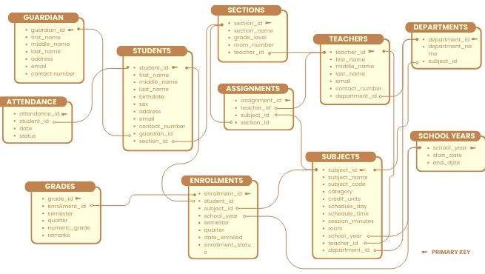
Theory

A School Management System stores information about students, teachers, classes, and grades. The database is designed using relations connected through primary and foreign keys to avoid redundancy and maintain data consistency.

Relations

  - STUDENT(StudentID, StudentName, ClassID, Grade)
  - CLASS(ClassID, ClassName, TeacherID)
  - TEACHER(TeacherID, TeacherName)
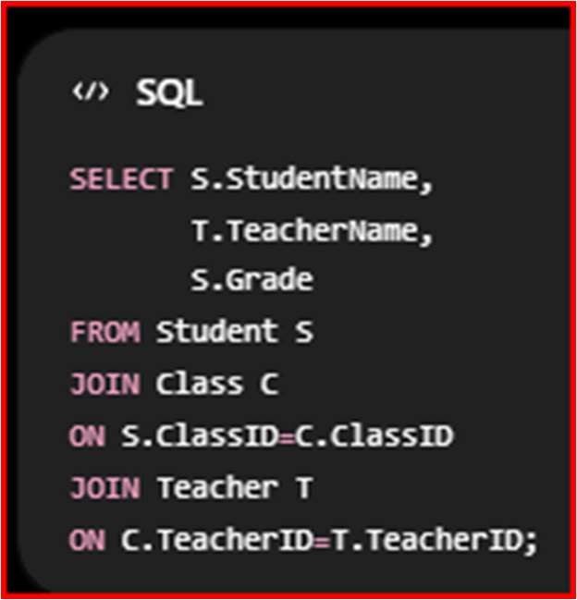

Hospital Appointment System
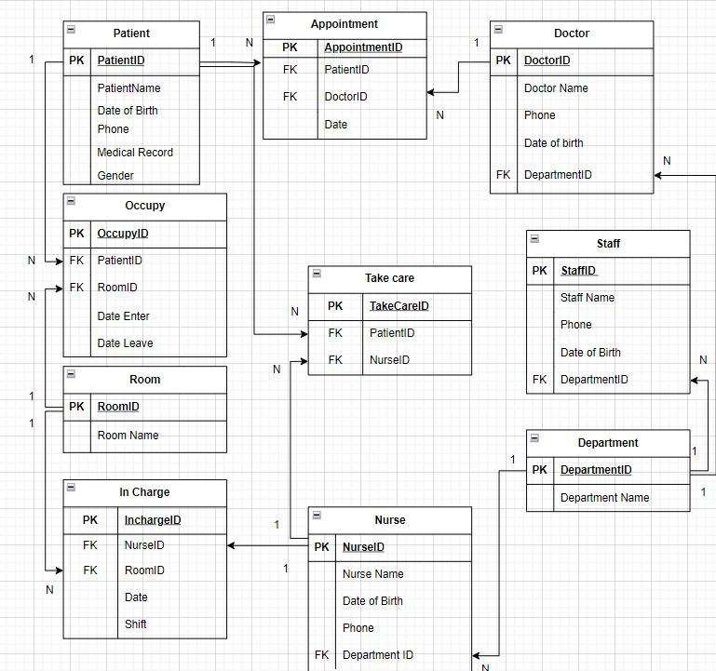

Theory
A Hospital Management System stores patient details, doctor information, and appointment records.

Relations

  - Patient(PatientID, Name)
  - Doctor(DoctorID, DoctorName, Specialization)
  - Appointment(AppointmentID, PatientID, DoctorID, AppointmentDate)

SQL Query

Doctors having more than 10 appointments this month.

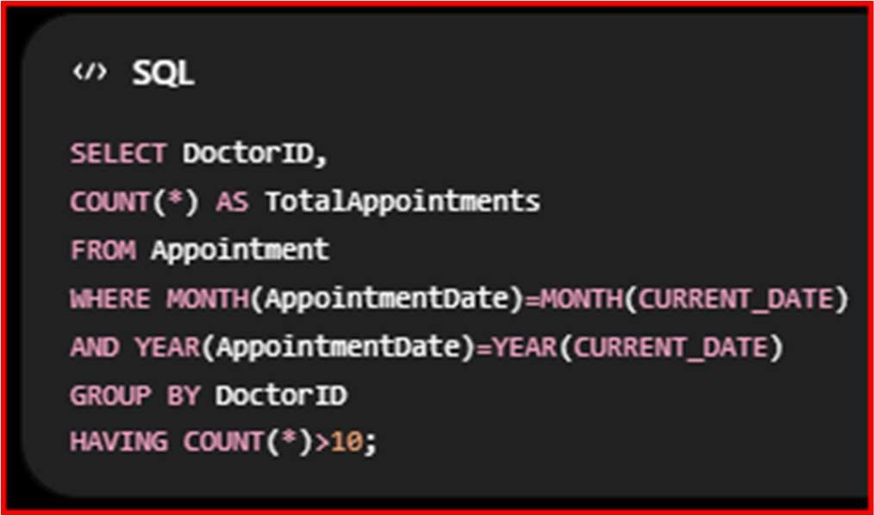

E-Commerce System

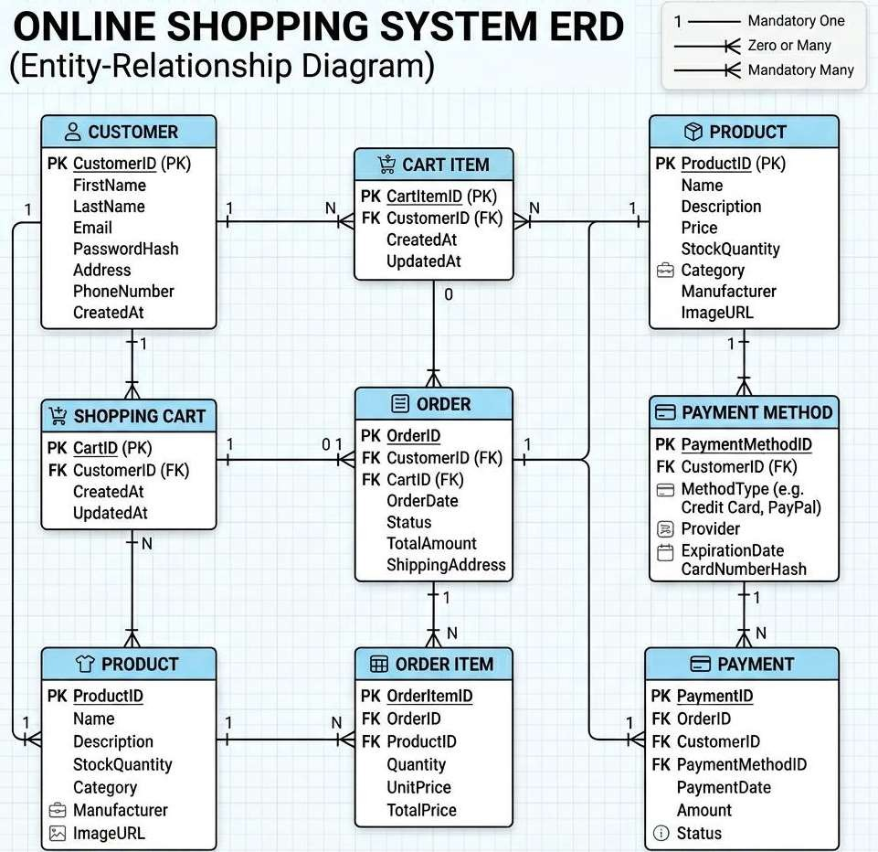

Theory
An E-commerce database maintains products, customers, and orders.

Relations

  - Product
  - Customer
  - Orders

  - OrderDetails

SQL (Sub-query)

Products that have never been ordered.
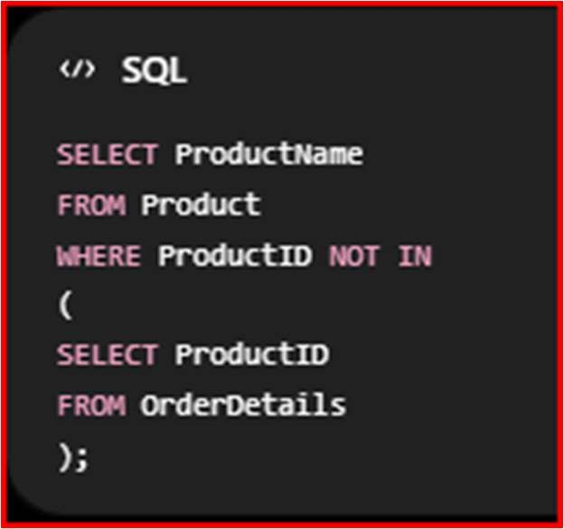

University Database
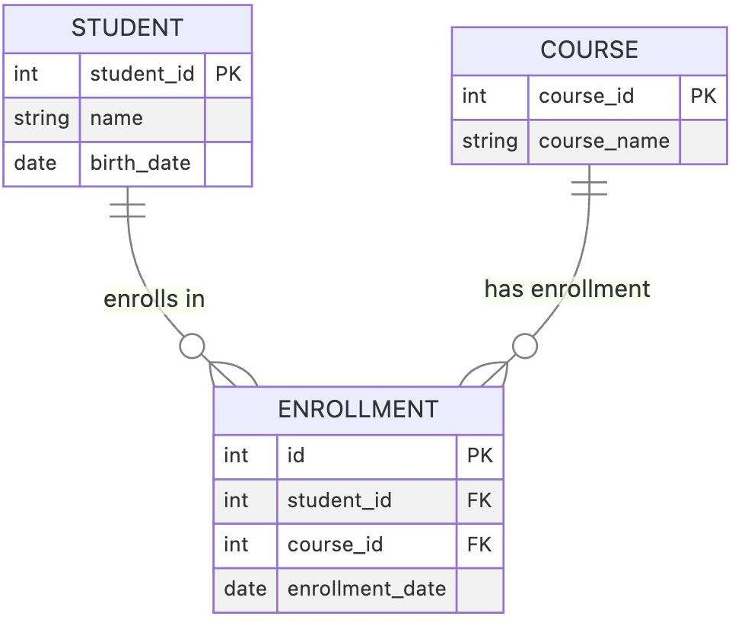

Theory
Students enroll in multiple courses through an Enrollment table.

Relations

Student(SID, Name) Course(CID, CourseName)

Enrollment(SID, CID)

Relational Algebra

Students enrolled in both DBMS and OS

πSID(σCourse=′DBMS′(Enrollment))∩πSID(σCourse=′OS′(Enrollment))

This returns students enrolled in both courses.

Payroll Management System
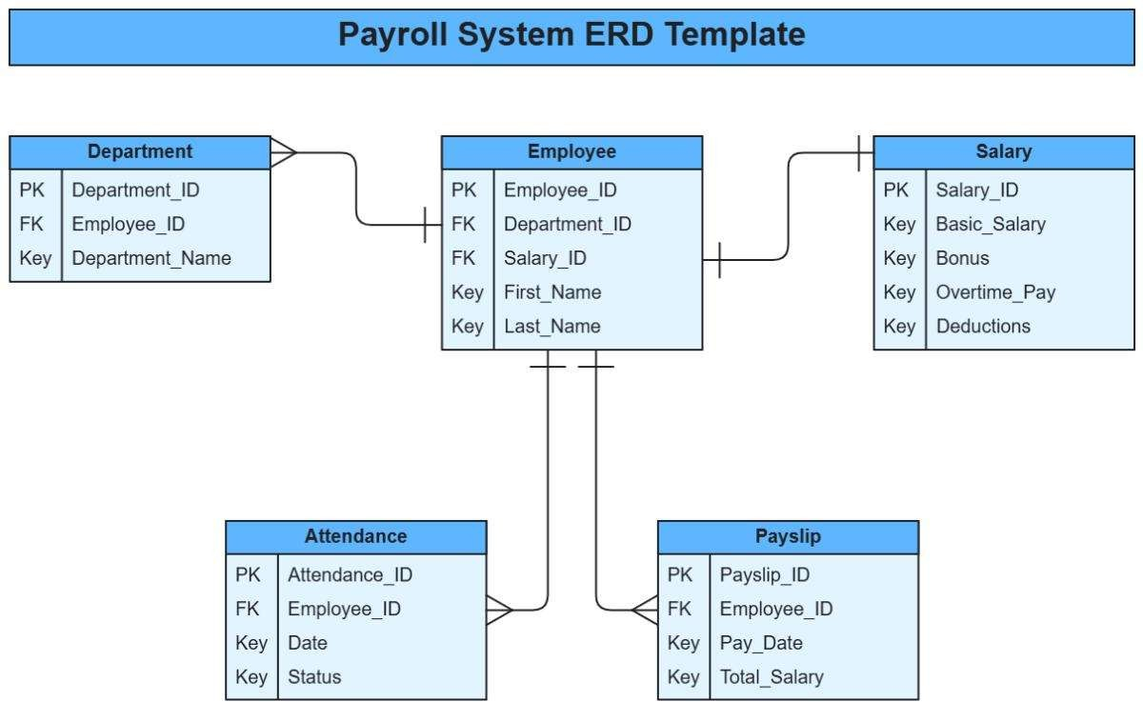

Theory
Payroll systems calculate employee salaries based on department and designation.

View
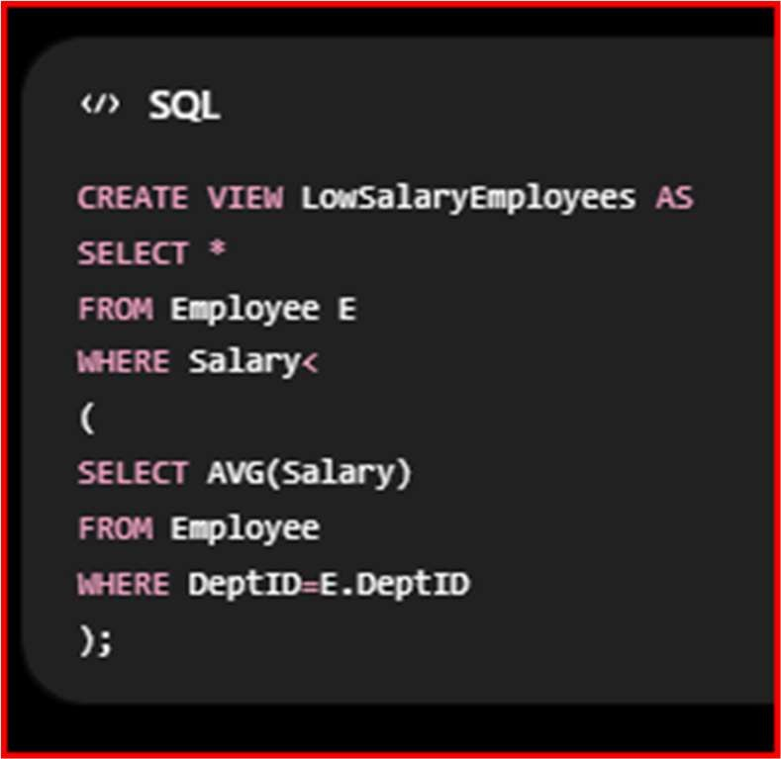
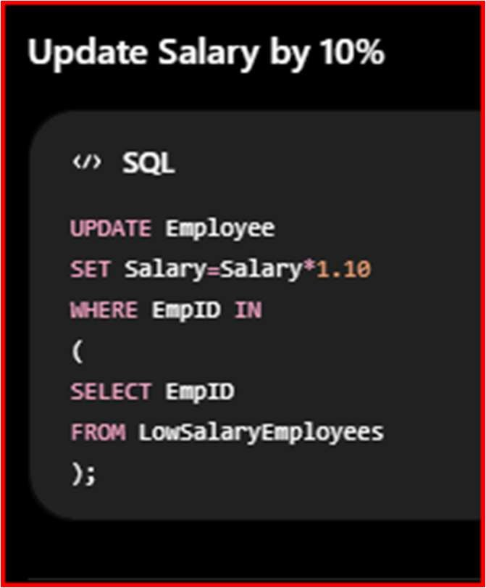

Banking System
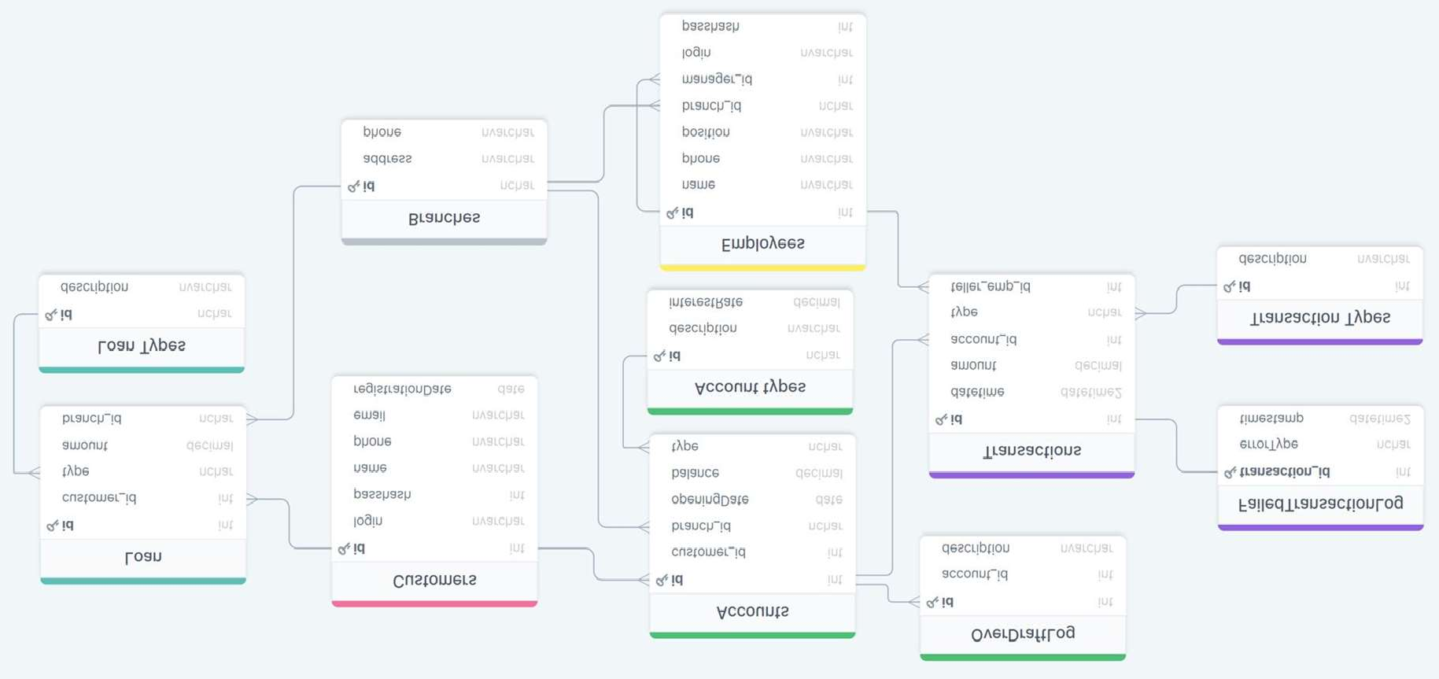

Theory
A Banking System stores customers, accounts, transactions, and branch information.

Relations

  - Customer
  - Account
  - Transaction
  - Branch SQL Join

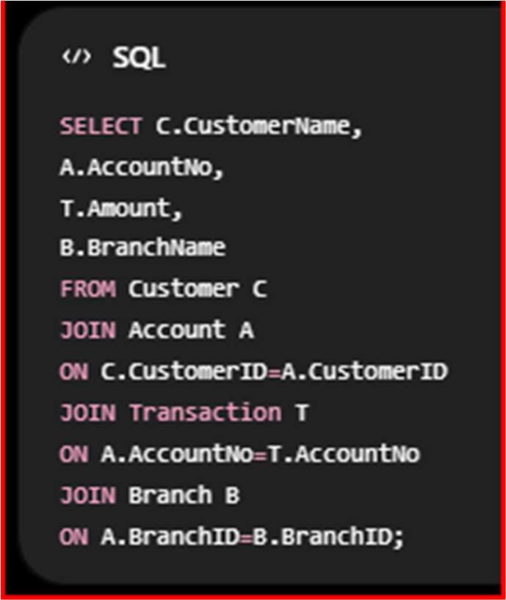

Retail Store
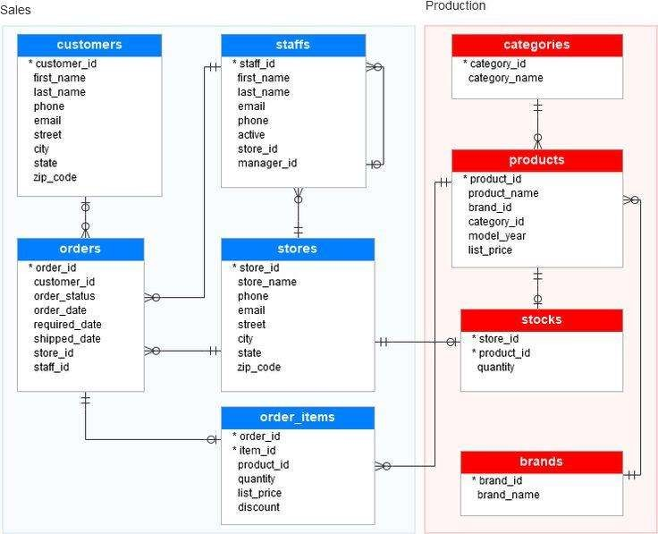

Theory
Retail stores analyze daily sales using aggregate functions.

SQL
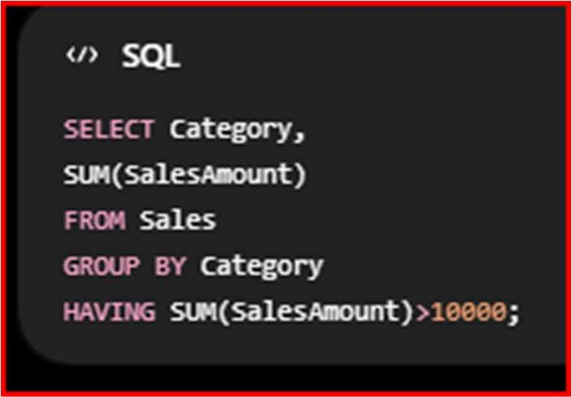

The GROUP BY clause groups products by category, while HAVING filters categories whose total sales exceed ₹10,000.

Library Management System

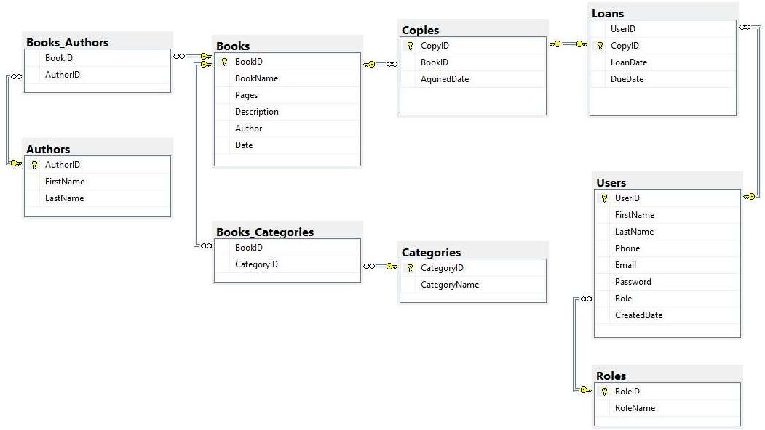
Theory

Library databases store members, books, genres, and borrowing records.

Tuple Relational Calculus

Members who borrowed books from all genres.

{m∣Member(m)∧∀g(Genre(g)→∃b(Borrow(m,b)∧BookGenre(b,g)))}

This query returns members who have borrowed at least one book from every available genre.

Inventory Management System
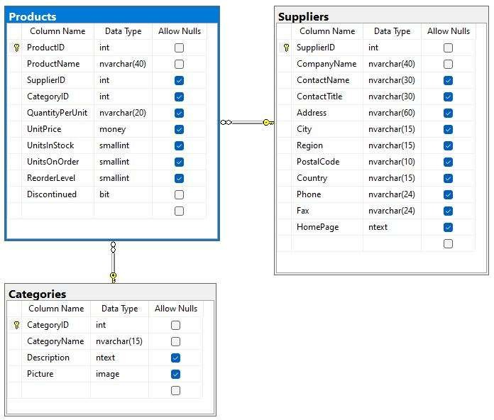
Theory
Inventory Management keeps track of products, suppliers, and stock availability.

Constraints

CHECK Constraint
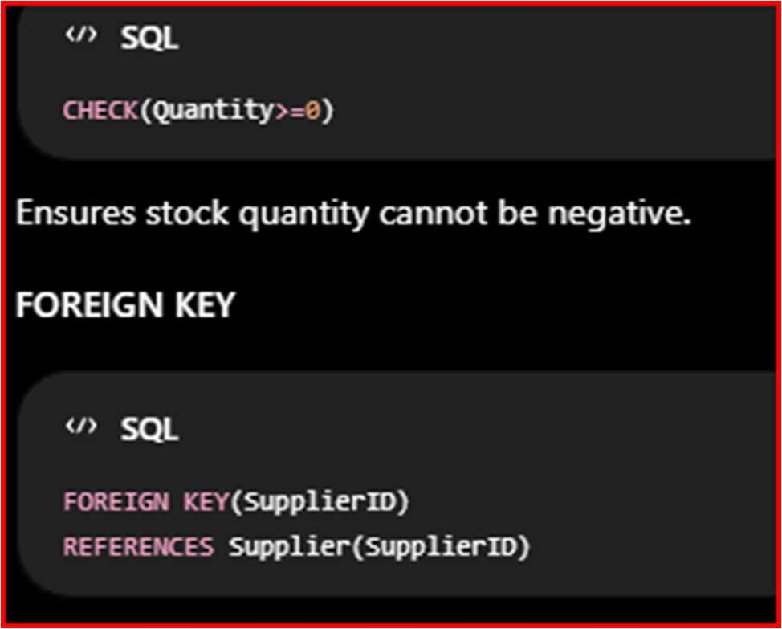

Ensures every product belongs to a valid supplier.

Enforcement

- Inserting a product with a negative quantity violates the CHECK constraint.
- Inserting a product with a non-existent SupplierID violates the FOREIGN KEY constraint.

Thus, constraints help maintain data integrity.

HR Management System

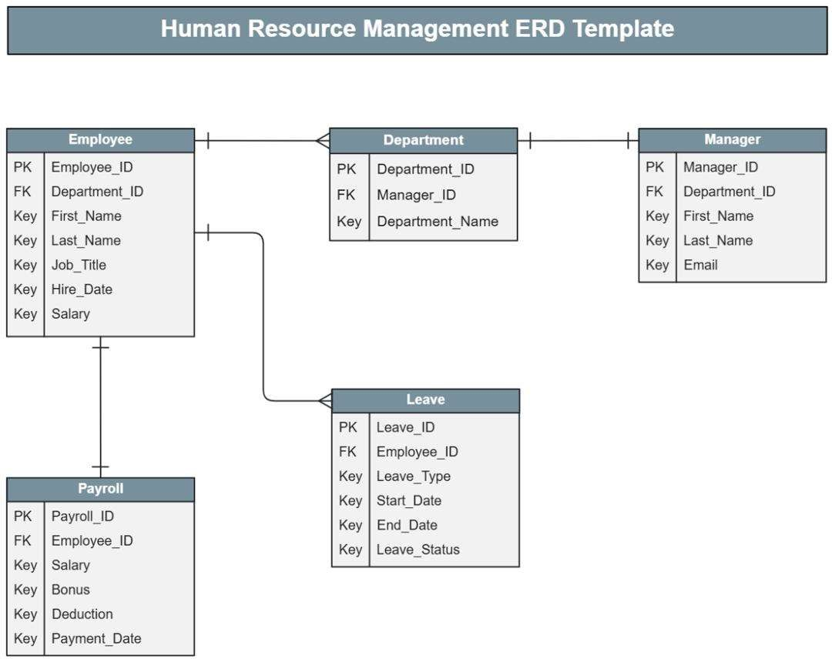

Theory
An HR Management System stores employee details, attendance records, departments, salaries, and performance evaluations.

Relations

  - Employee
  - Department
  - Attendance
  - Performance

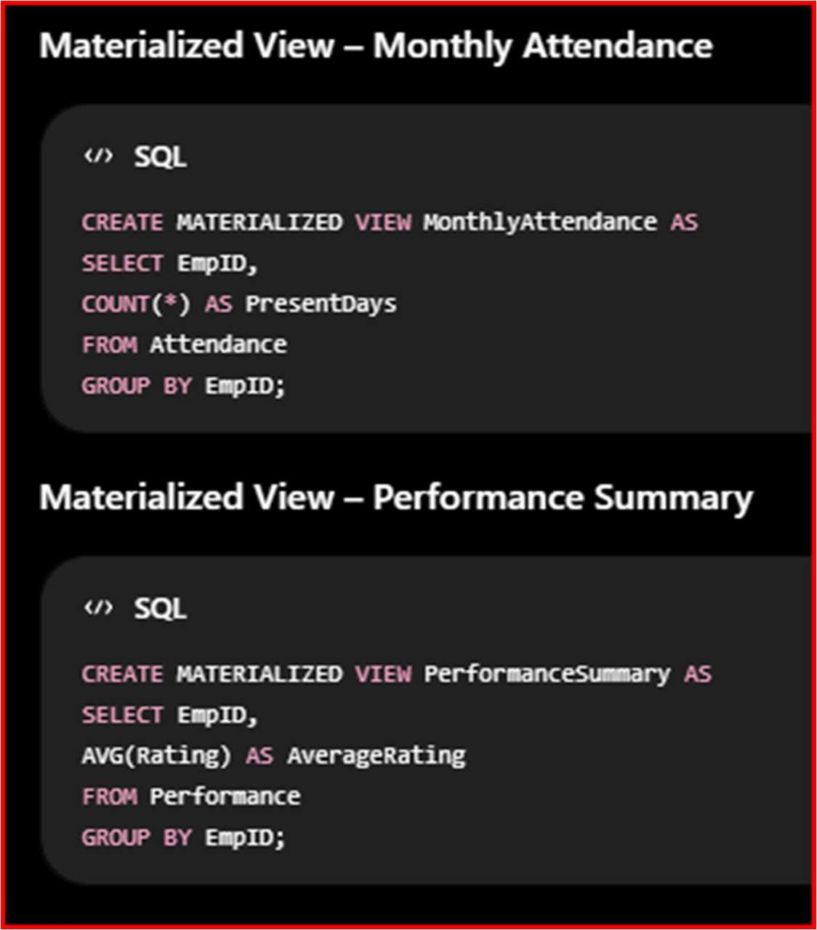

Advantages of Materialized Views

  - Improves query performance.
  - Stores precomputed results.
  - Reduces execution time for complex queries.
  - Useful for reporting and analytics.
  - Minimizes repeated calculations.

These theory explanations, ER-style diagrams, and SQL examples are suitable for 10-mark university examination answers and can be written directly in your DBMS exam.

